2020

:Liam Hulsman-Benson

N9960392

9/14/2020

r/food Recipe Finder



CAB432 Assignment 1

Contents

Introduction 2

Mashup Purpose & description 2

Services used 3

Reddit search API 3

Edamam Recipe Search API 3

Edamam Food Database Search API 3

Mashup Use Cases and Services 3

UC 1 3

UC 2 4

UC 3 4

UC 4 5

Technical breakdown 5

Architecture and Data Flow 5

Deployment and the Use of Docker 8

Test plan 8

Difficulties / Exclusions / unresolved & persistent errors 10

Extensions (Optional) 11

User guide 11

Statement on Assignment Demo 12

References 12

Appendices 13

Appendix 1: Dockerfile with hidden link. 13

Appendix 2: Test Images 13

## Introduction

### Mashup Purpose & description

The designed and developed application is a combination of three APIs allow the user to view the top posts of the subreddit r/food from the past 24 hours, Figure 1. The application then allows the user to search a recipe database and returns a list of relevant recipes for the selected post. Further adding to the application, the ingredients listed in the recipe will be returned with the corresponding nutritional facts if applicable. This application allows users to find food recipes that they find appealing, get a recipe and be able to view and remove ingredients from the recipe which may not suit their diet, Figure 2.

### 

Figure : Top posts of r/food from the last 24 hours

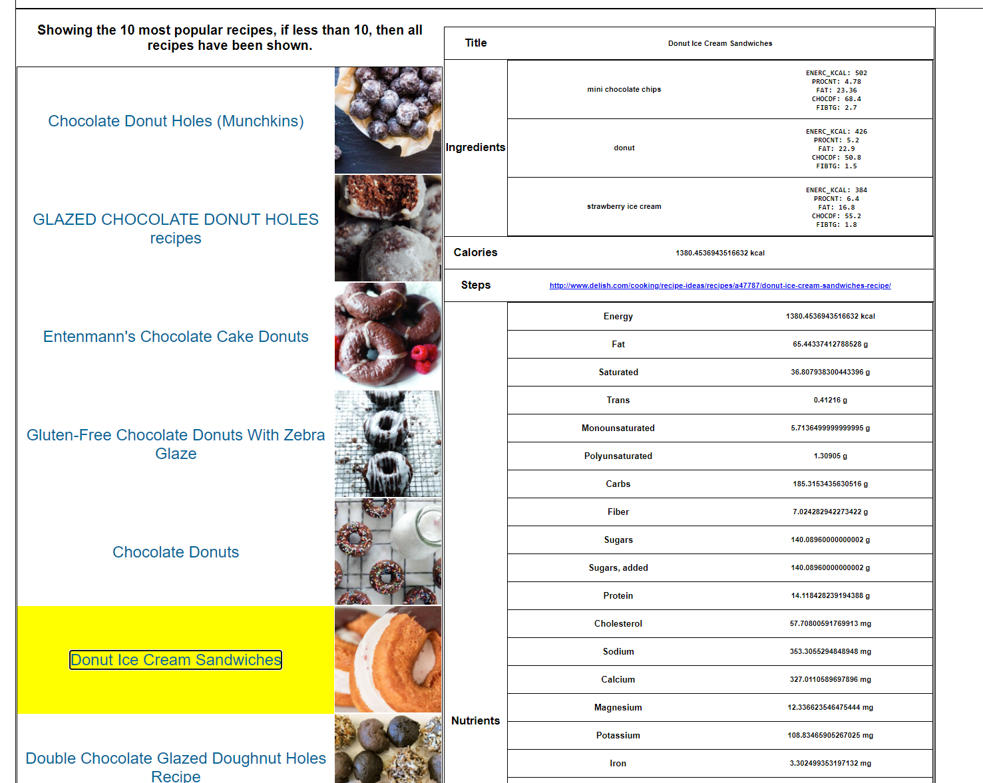

Figure : Selected recipe in yellow with nutrients for individual ingredients shown in the top right.

### Services used

#### Reddit search API

|  |  |
| --- | --- |
| *Return a collection of posts matching the specified query. Can be filtered by reddit standards, (top, rising,ect) Can also be limited to specific subreddits.* | |
| ***Endpoint:*** | www.reddit.com/search.json |
| ***Docs:*** | [*https://www.reddit.com/dev/api/*](https://www.reddit.com/dev/api/) |

#### Edamam Recipe Search API

|  |  |
| --- | --- |
| *Return a collection of recipes that match the specified query. Can search for recipes with key words or given a uri for a recipe a specific recipe can be selected. Can also specify a range of other options such as prep time and dish type.* | |
| ***Endpoint:*** | https://api.edamam.com/search |
| ***Docs:*** | [*https://developer.edamam.com/edamam-docs-recipe-api*](https://developer.edamam.com/edamam-docs-recipe-api) |

#### Edamam Food Database Search API

|  |  |
| --- | --- |
| *Returns a list of likely food items, with each listing containing the nutrients about the item. Can search for food items by their name or by their UPC code.* | |
| ***Endpoint:*** | https://api.edamam.com/api/food-database/v2/parser |
| ***Docs:*** | [*https://developer.edamam.com/food-database-api-docs*](https://developer.edamam.com/food-database-api-docs) |

## Mashup Use Cases and Services

#### UC 1

|  |  |  |
| --- | --- | --- |
| As a | User looking for something to cook |  |
| I want | To be able to search a recipe database for specific keywords. |
| So that | I can find something appealing to cook. |

#### 

#### UC 2

|  |  |  |
| --- | --- | --- |
| As a | User looking for something to cook |  |
| I want | To browse r/food and find an appealing picture of food and search a food database for recipes of that food item. |
| So that | I can cook something I find appealing. |

#### UC 3

|  |  |  |
| --- | --- | --- |
| As a | Healthy individual who wants to cook something |  |
| I want | To give a list of items to return the nutrients of each food item. |
| So that | I can be sure that what I am adding to a recipe is good for me. |

#### 

#### UC 4

|  |  |  |
| --- | --- | --- |
| As a | Healthy individual who wants to cook something |  |
| I want | To view the nutrition of each food item in a recipe |
| So that | I can be remove items from a recipe if it does not suit my diet. |

## Technical breakdown

### Architecture and Data Flow

When the user first lands on the homepage of the application the system shows the top-rated posts of the last 24 hours from r/food. This explains the routing of (1) as the eventual output, subsequent results and the input of the page. All pages displayed in the application inherit from the layout pug file, this allows for a standard section at the top of each page to add searching functionality that will be available on every page which a user can reach.

Each of the client-side JavaScript files link the respective pug files to the relevant server side routers. On the client side, Values are retrieved from input fields or button selections, then quickly sanitized by removing whitespace and illegal characters which are not permitted in the URL, then these values are sent via routing to the backend. Once backend routing is completed the page is redirected to the rendered pug page, this is true if the routing completes successfully or errors as either the results an error page is displayed. In two instances data is retrieved in the client-side JavaScript, displays for queried food items in the search box or the selection of a recipe from the recipe page. These are both then displayed in similar methods via updating fields on the HTML page, resulting in data being presented to the user without refreshing the page.

Each of the server-side JavaScript files is related to only one API, in the instance where data needs to be passed from one API to the another, the relevant API is called from within the other API call. This results in the APIs requiring promises to ensure data is returned before rending of the page is attempted, Figure 3.

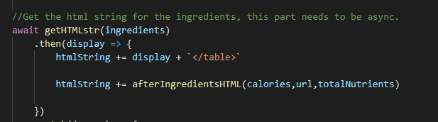

Figure : Function using await, to stop until the function returns a promise, from an API.

(2) represents a user’s search from the homepage in the food item nutrition search, Figure 4. The returned values are displayed by updating fields in the HTML file via JavaScript resulting in the page not requiring to be re-rendered, Figure 5.

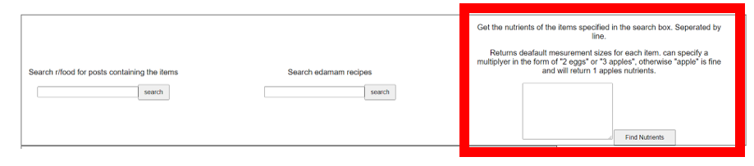

Figure : Highlighted food item nutrition search.

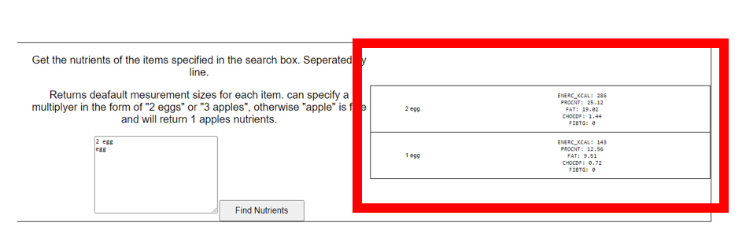

Figure : Highlighted returned results, from the food nutrition item search.

(3) represents a user’s search for a recipe, this can be from a selection of a reddit post or manually searching in the search field, Figure 6. This is the input of the recipe view page as it gets the names and pictures of all recipes and displays them and allows the user to scroll through the pages. This API does not directly link to the nutrition API until a recipe is selected from the list. At that point the right-hand side of the page, Figure 7, displays information about the recipe and the nutritional facts for each food item is displayed in the recipe, (4). The facts are displayed if possible in a majority of cases however the items are just listed, this is due to the free version of the Edamam API does not return ingredients are an ingredient data structure, Figure 8, but rather just a text field, which results in getting the measurements from the text requires natural language processing to occur. If a higher version of the API was used the measurements could be displayed a large majority of the time due to the data structure interface.

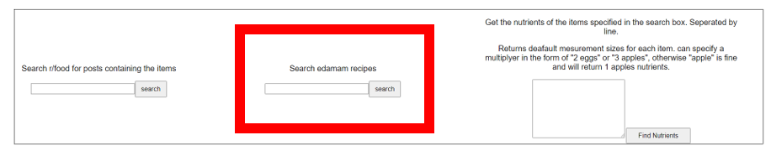

Figure : Search for a recipe directly from the Edamam database

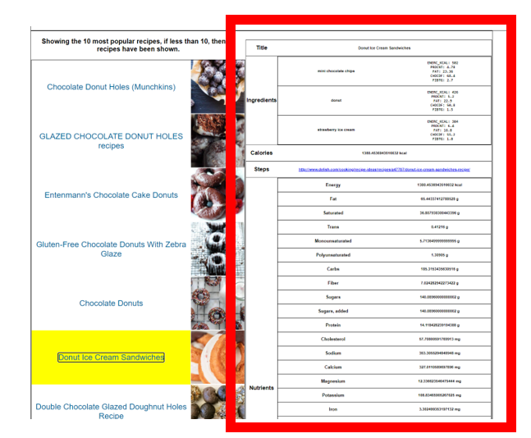

Figure : Highlighted recipe on left, is shown on the RHS.

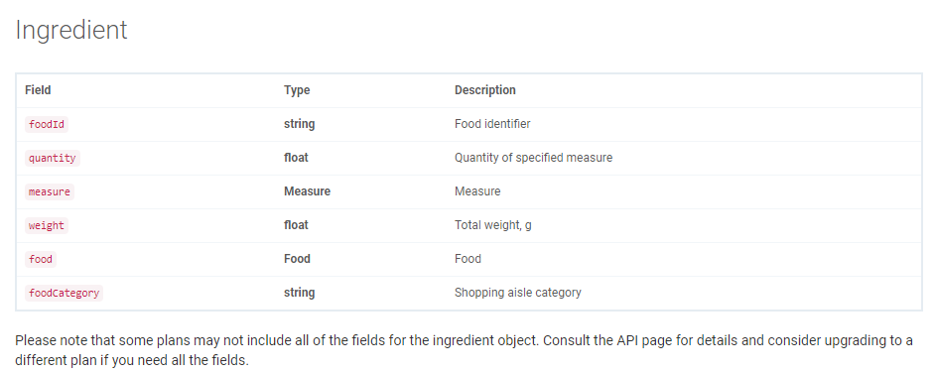

Figure : Edamam API documentation, stating below that not all results will return all the values in the ingredient object. But can for a higher tier.

For error checking results are sanitized for unexpected characters and a catch with a render is used with every API call, to ensure a page is always rendered even in the case of no data being found. Additionally, a router was added at the end of the app.js file which catches all URLs which does not fall into one of the previous routers.

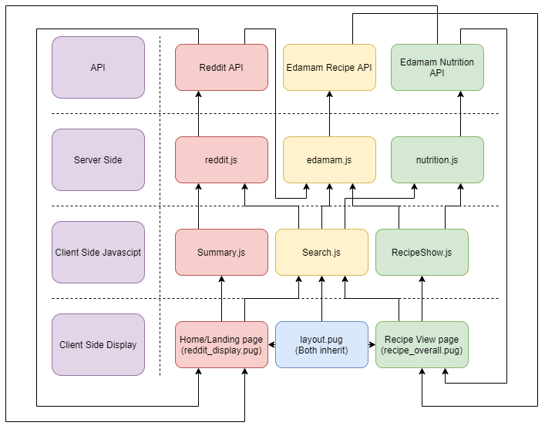

### Deployment and the Use of Docker

*Docker was used to load in the corresponding modules for the program and execute the program. The Docker file first grabs the latest node version, then checks for updates to the OS and downloads GIT. The latest version of the app is grabbed from github, if the docker file is build multiple times need to ensure the no-cache tag is used in the building process to ensure the latest version of the app is grabbed from github. This github line is not required as an the files can be grabbed manually before building, however this just ensures this step is not skipped over. The file then changes to the appropriate working directory, installs NPM and exposes the port, 3000. The app is then executed, which can now be accessed on the IP specified on AWS.*

The full Docker file can be viewed in appendix 1

*(Note, The docker file will not execute as the link was manually changed, otherwise anyone with the link could access my private repos.)*

### Test plan

|  |  |  |  |
| --- | --- | --- | --- |
| **ID** | **Task** | **Expected Outcome** | **Result** |
| 1 | Load home page | Posts are shown with images and links and previous button is unavailable | Pass |
| 2 | Go to next page of Reddit results | Posts are shown with images and links. Next and previous page buttons are available | Pass |
| 3 | Back to Previous page of reddit results | Same outcome as Task 1 | Pass |
| 4 | Search reddit posts, input eggs | Same outcome as Task 1, however posts only correspond to the input search term. | Pass |
| 5 | Search reddit posts with no posts returning | No posts found page displayed. | Pass |
| 6 | Click on Title of reddit post to go to reddit webpage for the post | Reddit website opens to the corresponding post. | Pass |
| 7 | Clicking on the image of the reddit post. | Image is loaded on a new page at an increased size. | Pass |
| 8 | A reddit post is selected with no recipes available | No recipes page is shown, then after 5 seconds return to the previous page | Pass |
| 9 | A recipe is searched in the recipe search field which has no results. | Same outcome as Task 8 | Pass |
| 10 | Search a valid recipe in the recipe search box | A list of recipes are shown on the LHS of the screen, with no details of any recipe yet. The previous button is disabled and the next page button in enabled. | Pass |
| 11 | Continuing Test 10 Click a recipe title on the LHS | The page does not reload from Test 10, the selected recipe is highlighted and its details appear on the RHS. | Pass |
| 12 | The Selected recipe has data in a format that the nutrition information can be displayed | Nutritional information for each food item listed in the ingredients section is displayed. | Pass |
| 13 | The selected recipe has ingredients in a format that nutritional information cannot be displayed for it. | Ingredients are listed in the ingredients section of the page, with no nutritional data. | Pass |
| 14 | The link to the steps is clicked | An external site hosting the recipe opens to show the steps of the recipe. | Pass |
| 15 | The next button is clicked on the recipes page. | The next page is loaded with recipes still on t he same search query. Both the previous and next buttons are enabled. | Pass |
| 16 | The previous button is clicked on the recipes page. | Same outcome as Test 10 | Pass |
| 17 | A bad item is input into the food item nutrient search | Does not reload the page, Displays the item cannot be found. | Pass |
| 18 | Multiple good items are input into the food item nutrient search. Separated by new lines. | Does not reload the page, displays nutrients for each item selected. | Pass |
| 19 | Multiple items are input into the food item nutrient search. Separated by new lines. Can be real or fake items | Does not reload the page, displays nutrients for what it can, otherwise say item cannot be found. | Pass |
| 20 | Click the home button in the top left | Same outcome as Test 1 | Pass |
| 21 | User can go back or forward pages by pressing the buttons built into the browser. | Goes back or forward to the correct page, depending which button is pressed. | Pass |
| 22 | A bad url is used that is not expected. This URL was entered manually as unsure if it is possible to add it in user input. | An unexpected page error is shown, then returns to previous page after 5 seconds. | Pass |

Difficulties / Exclusions / unresolved & persistent errors /

The largest roadblock encountered in the development of the application was promises and API timings. The documentation for promises and awaits were not straightforward and resulted in the program rendering a page with no data as the API did not yet return. With messing around with awaits and examples eventually a solution was found. However, I am sure it is far from optimal for such an application.

One unexpected error with the Edamam API was that when using the free version of the recipe api, it returned ingredient items as a string of text instead of an ingredient item as was expected from the documentation, Figure 8. This resulted in extracting the measurements impossible without some natural language processing, which was not included in the project. If a higher level of the API was used it does return ingredients as an item allowing for the measurements to be grabbed from a JSON file making the combination of APIs easier.

The free API does have a limit of 5 requests per minute, which will cause the program to hang for a while, as it is requesting data but not receiving anything back. This can again be fixed with an increase in API tier. Finally, regarding the Edamam API, the steps for recipes are not in the returned JSON, rather just a link to the steps.

The final product differed from the original design as reddit was used instead of the flicker API. This was due to flicker not adding enough or good tags to the images, which resulted in poor search queries. Reddit was found to have good titles for images in the subreddit r/food, therefore the titles of posts were used instead of tags. Otherwise, the project is much the same as the original design.

## Extensions (Optional)

Obviously, the app could be improved with the inclusion of a higher tier of API from EDAMAM, therefore the two Edamam APIs could be integrated better. Additionally, some more work could be done to the front end such as a nice look and more JavaScript updates to the HTML to make for a reactive page instead of the currently mostly static one.

## User guide

To return home (the landing page), you can click the home button in the top left, Figure 9. From here, you can view the list of top posts from r/food. If you click on the title of the post, on the left side of the picture, it will bring you to the reddit post on the reddit website. If the image is clicked a larger view of the image will appear. Finally, if you click get recipe a list of recipes relating to the post will appear. At the bottom of the page a previous and next page button will allow you to traverse posts. Initially the previous page button will be unavailable until you are past the first page.

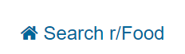

Figure : Home button

Once get recipe has been pressed the following page will appear, related to your selected post however, Figure 10. You can then click on the title of the recipe, in this example “Eggs in Bacon Baskets Recipe” was clicked, Figure 11. From here you can view details about the recipe or you can click the steps link, to go to the external page for list of steps required to make the recipe. You need to be careful on this step however as the API only allows for 5 requests per minute, one was used loading the page, 1 for each page change and 1 for each recipe that is selected. If the recipe does not change within 10 seconds it has likely reached its limit and will function again in 1 minute. Nothing needs to be done besides waiting for the minute to pass. Additionally, at the bottom of the page more buttons are present to traverse the list of recipes.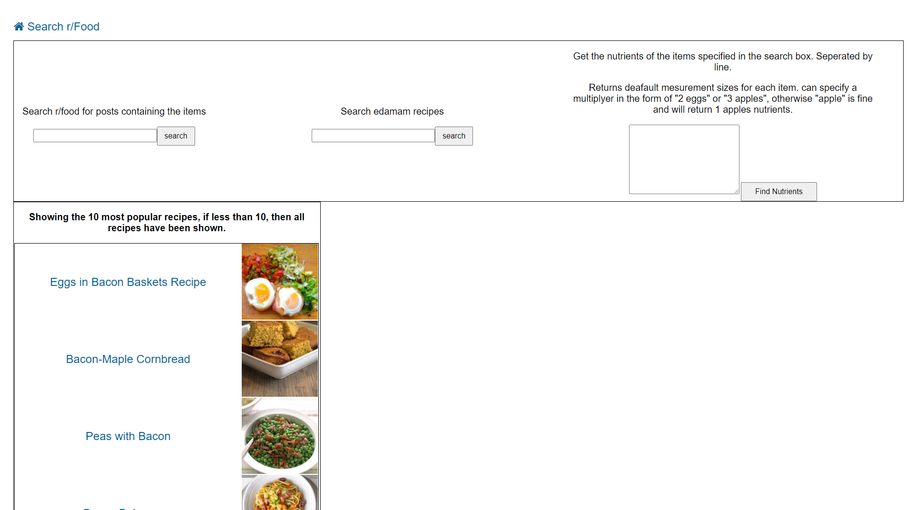

Figure : List of Recipes

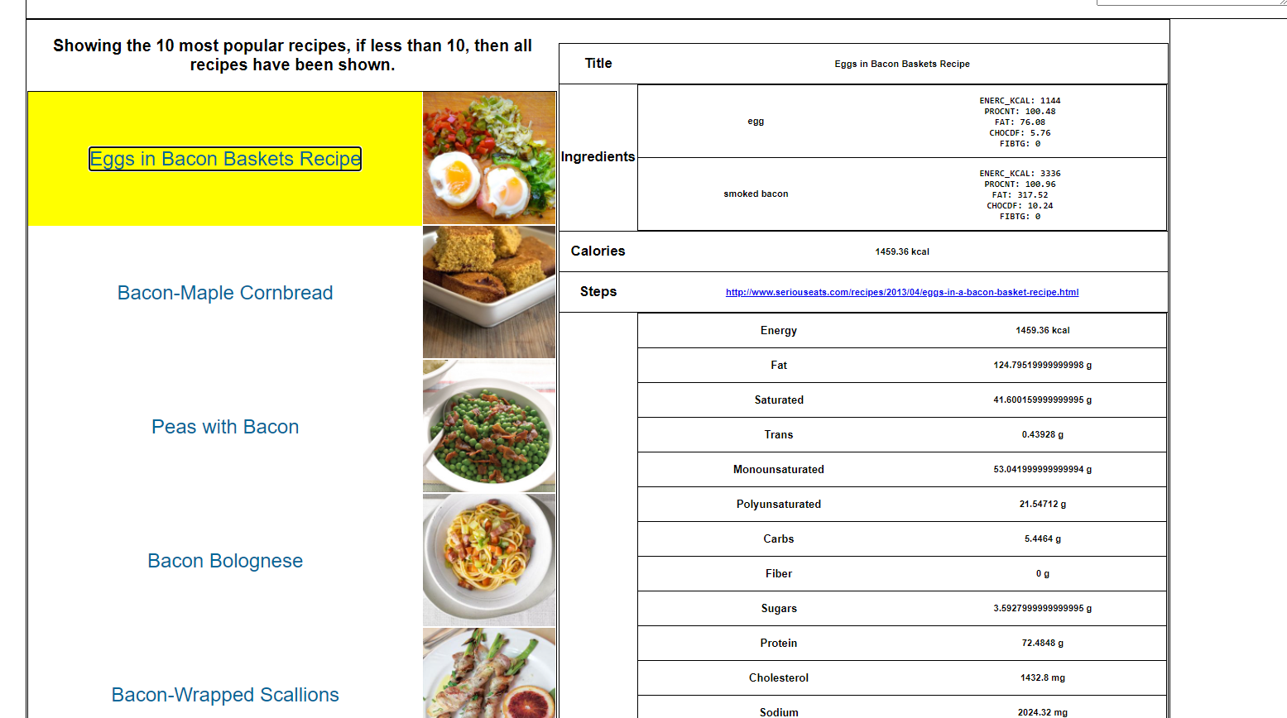

Figure : Selected Recipe shown

The final section is the searching at the top of every page, Figure 12. These text fields can be used on any page of the app and will return the corresponding parts. From the Left, is a reddit search where it will return posts from r/food relating to the query. The 2nd searches the Edamam recipe API for recipes with the inputted query. Finally, a list of items can be input into the field, separated by new lines to display the nutrients of the item. A number can be added to the front of the item as a multiplier. However, the free tier of the API does not allow for measurements, “cups” to be input for sizes, so just the default size will be returned. Each of there will bring you to a page you have seen previously if following the guide from the start and function in the same way. However, the food item API just displays the results from the query directly on the current page.

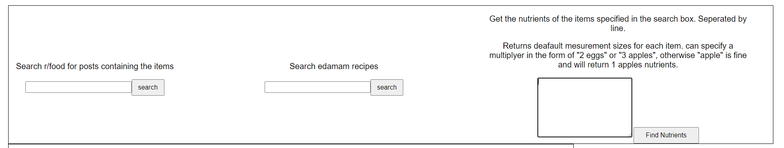

Figure : Searching inputs

## Statement on Assignment Demo

*A video is recorded and uploaded to YouTube. Link below*

*Link*

## References

1. reddit.com: api documentation. (2020). Retrieved 5 September 2020, from <https://www.reddit.com/dev/api/>
2. Recipe Search API Documentation. (2020). Retrieved 5 September 2020, from <https://developer.edamam.com/edamam-docs-recipe-api>
3. Food Database API Documentation. (2020). Retrieved 5 September 2020, from <https://developer.edamam.com/food-database-api-docs>

## Appendices

### Appendix 1: Docker file with hidden link.

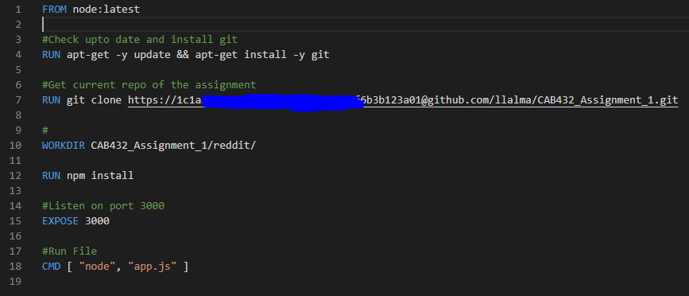

### Appendix 2: Test Images

|  |  |
| --- | --- |
| 1. |  |
| 2. |  |
| 3. |  |
| 4. |  |
| 5. |  |
| 6. |  |
| 7. |  |
| 8. |  |
| 9. |  |
| 10. |  |
| 11. |  |
| 12. |  |
| 13. |  |
| 14. |  |
| 15. |  |
| 16. |  |
| 17. |  |
| 18. |  |
| 19. |  |
| 20. |  |
| 21. |  |
| 22. |  |